[YOUR ORGANIZATION NAME]
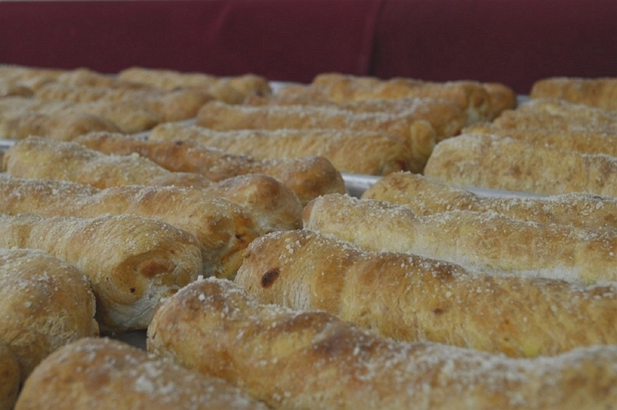
THAT’S A WRAP ROLLS COME IN 3 VARIETIES
PEPPERONI AND CHEESE | PEPPERONI AND SPICY JACK CHEESE | GARLIC AND CHEESE (NO PEPPERONI)

fundraiser

Pepperoni

Roll
THREE DELICIOUS VARIETIES SOLD IN PACKS OF 6 FOR $13.00. ROLLS ARRIVE FRESH, NOT FROZEN IN SAFE TAMPER PROOF RE-SEALABLE BAGS.
OUR GROUP PROFITS $6.50 FOR EACH PACK SOLD!!
SALES SHEETS DUE BY: [INSERT DATE]
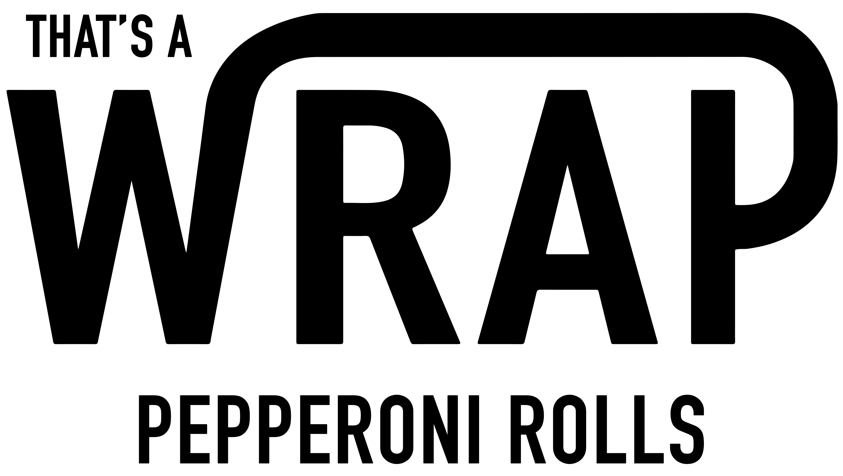
ROLLS ARRIVE ON: [INSERT DATE]

