[YOUR ORGANIZATION NAME]
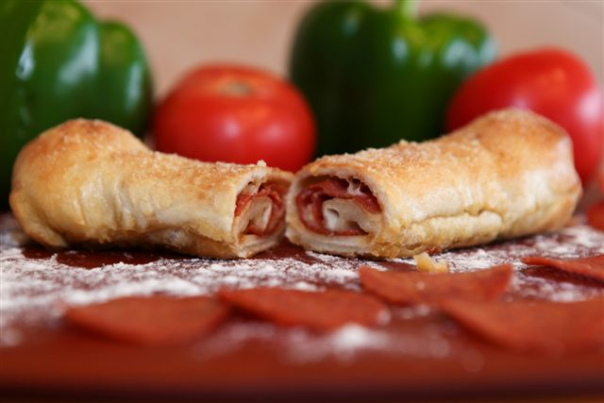

fundraiser

Pepperoni

Roll
THAT’S A WRAP ROLLS COME IN 3 VARIETIES
PEPPERONI AND CHEESE | PEPPERONI AND SPICY JACK CHEESE | GARLIC AND CHEESE (NO PEPPERONI)

WE ARE SELLING PEPPERONI ROLLS TO RAISE MONEY FOR OUR [INSERT FUNDRAISING EVENT]. THE ROLLS ARE SOLD IN PACKS OF 6 FOR $13.00 AND OUR GROUP WILL MAKE $6.50 FOR EACH PACK SOLD!!!
THE ROLLS ARE FRESH, NOT FROZEN AND ARE PACKED IN TAMPER PROOF RESEALABLE BAGS THAT CAN BE PLACED DIRECTLY IN THE REFRIGERATOR OR FREEZER.
SALES SHEETS ARE DUE BY [INSERT DATE] AND THE ROLLS WILL BE DELIVERED TO US ON [INSERT DATE].
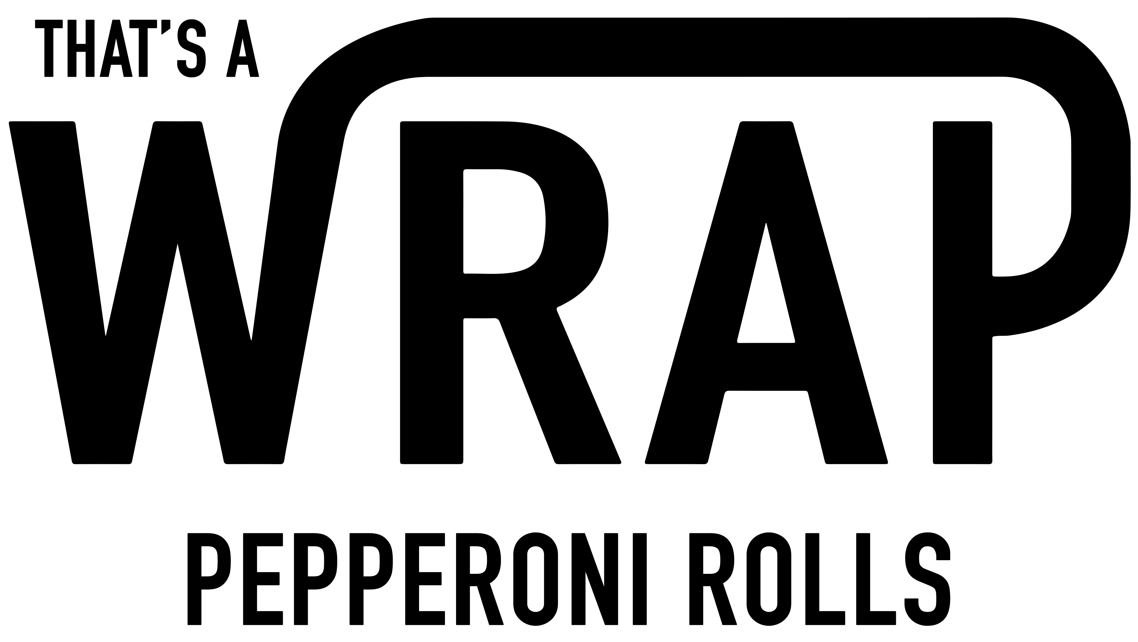
CHECKS CAN BE MADE PAYABLE TO [INSERT NAME].

